1. **Movies Analysis**

-Box office collection (Bar: Worldwide Lifetime gross Dots: Domestic percentage)

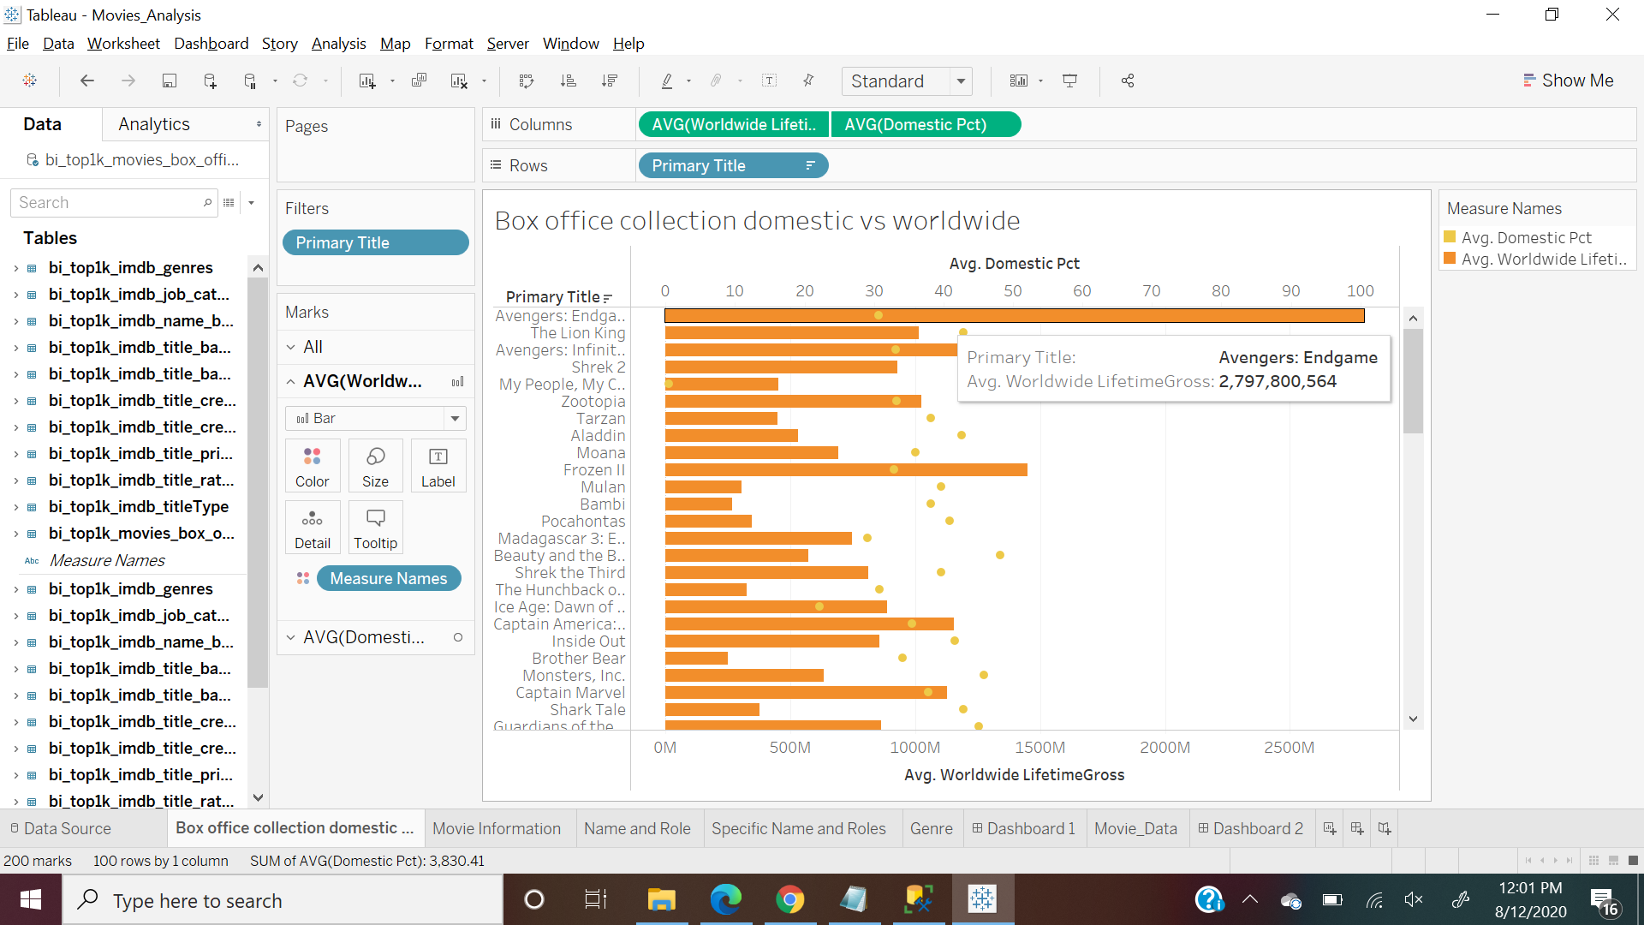

Movies Information

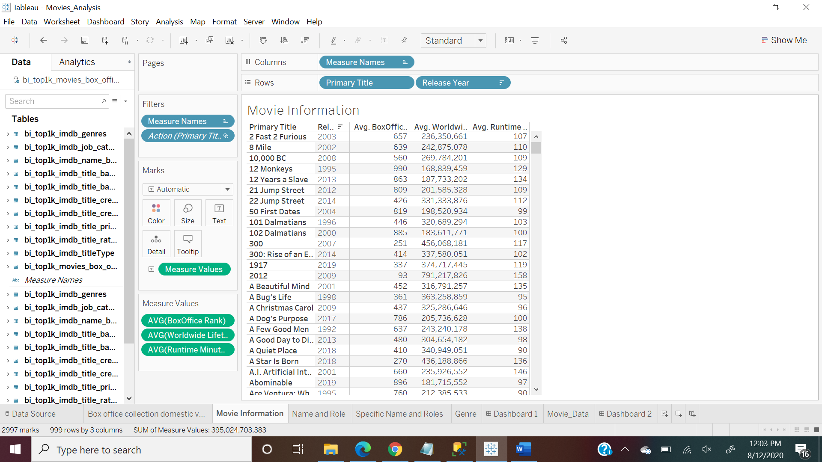

Name, Roles and Birth Year of People associated with top 1000 movies

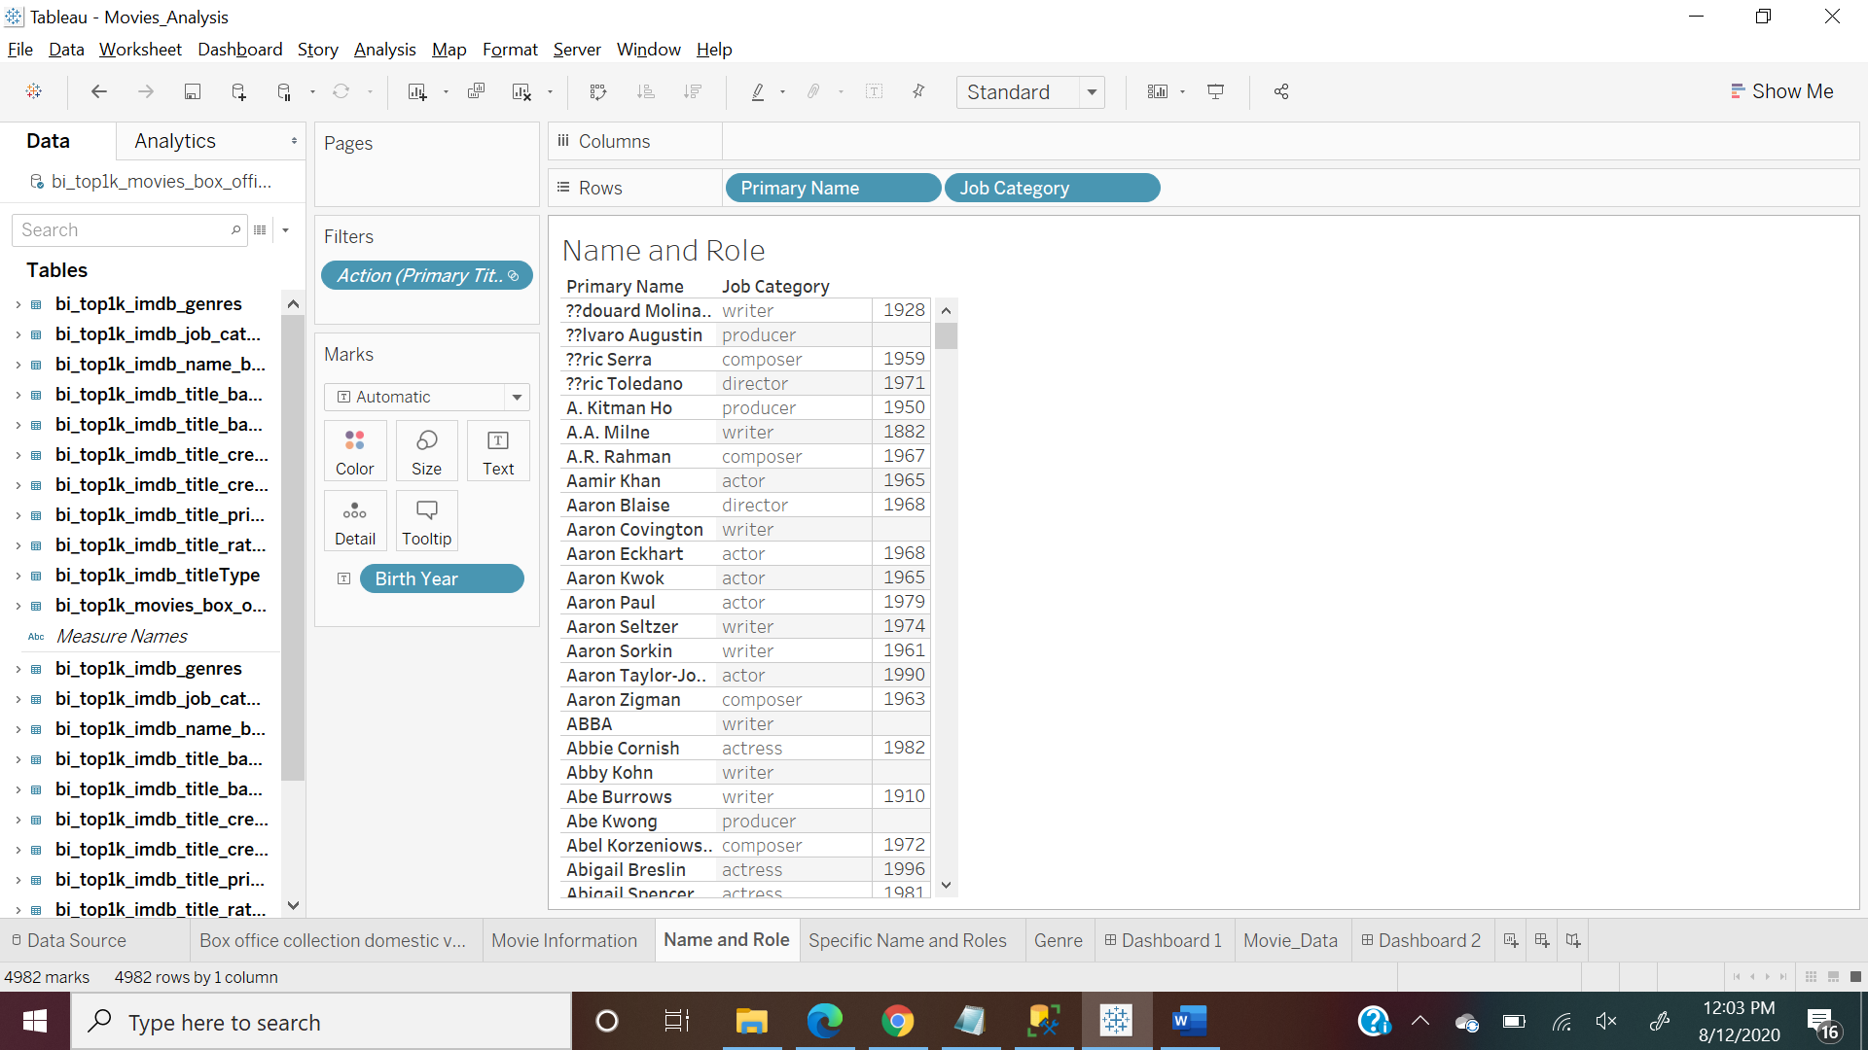

Specific names and roles (With applied given filters on names)

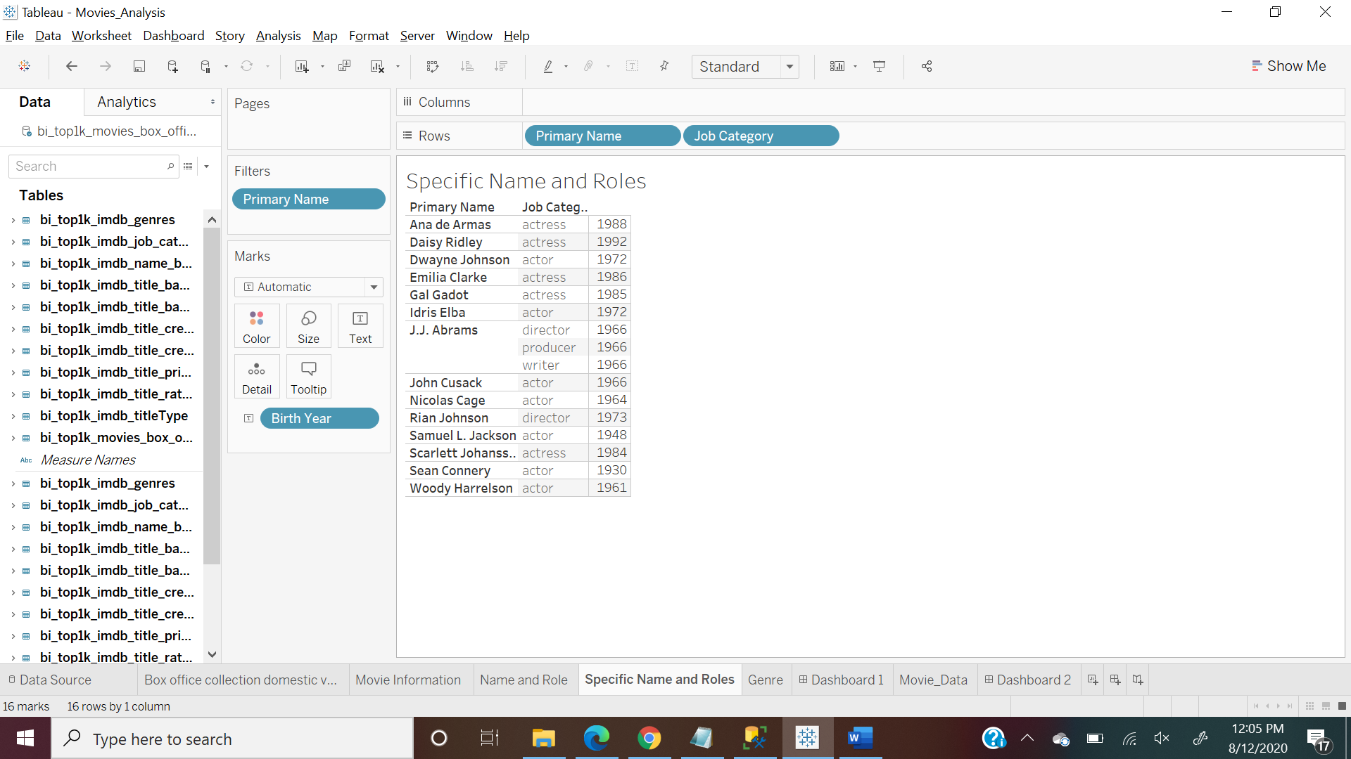

Genre Information

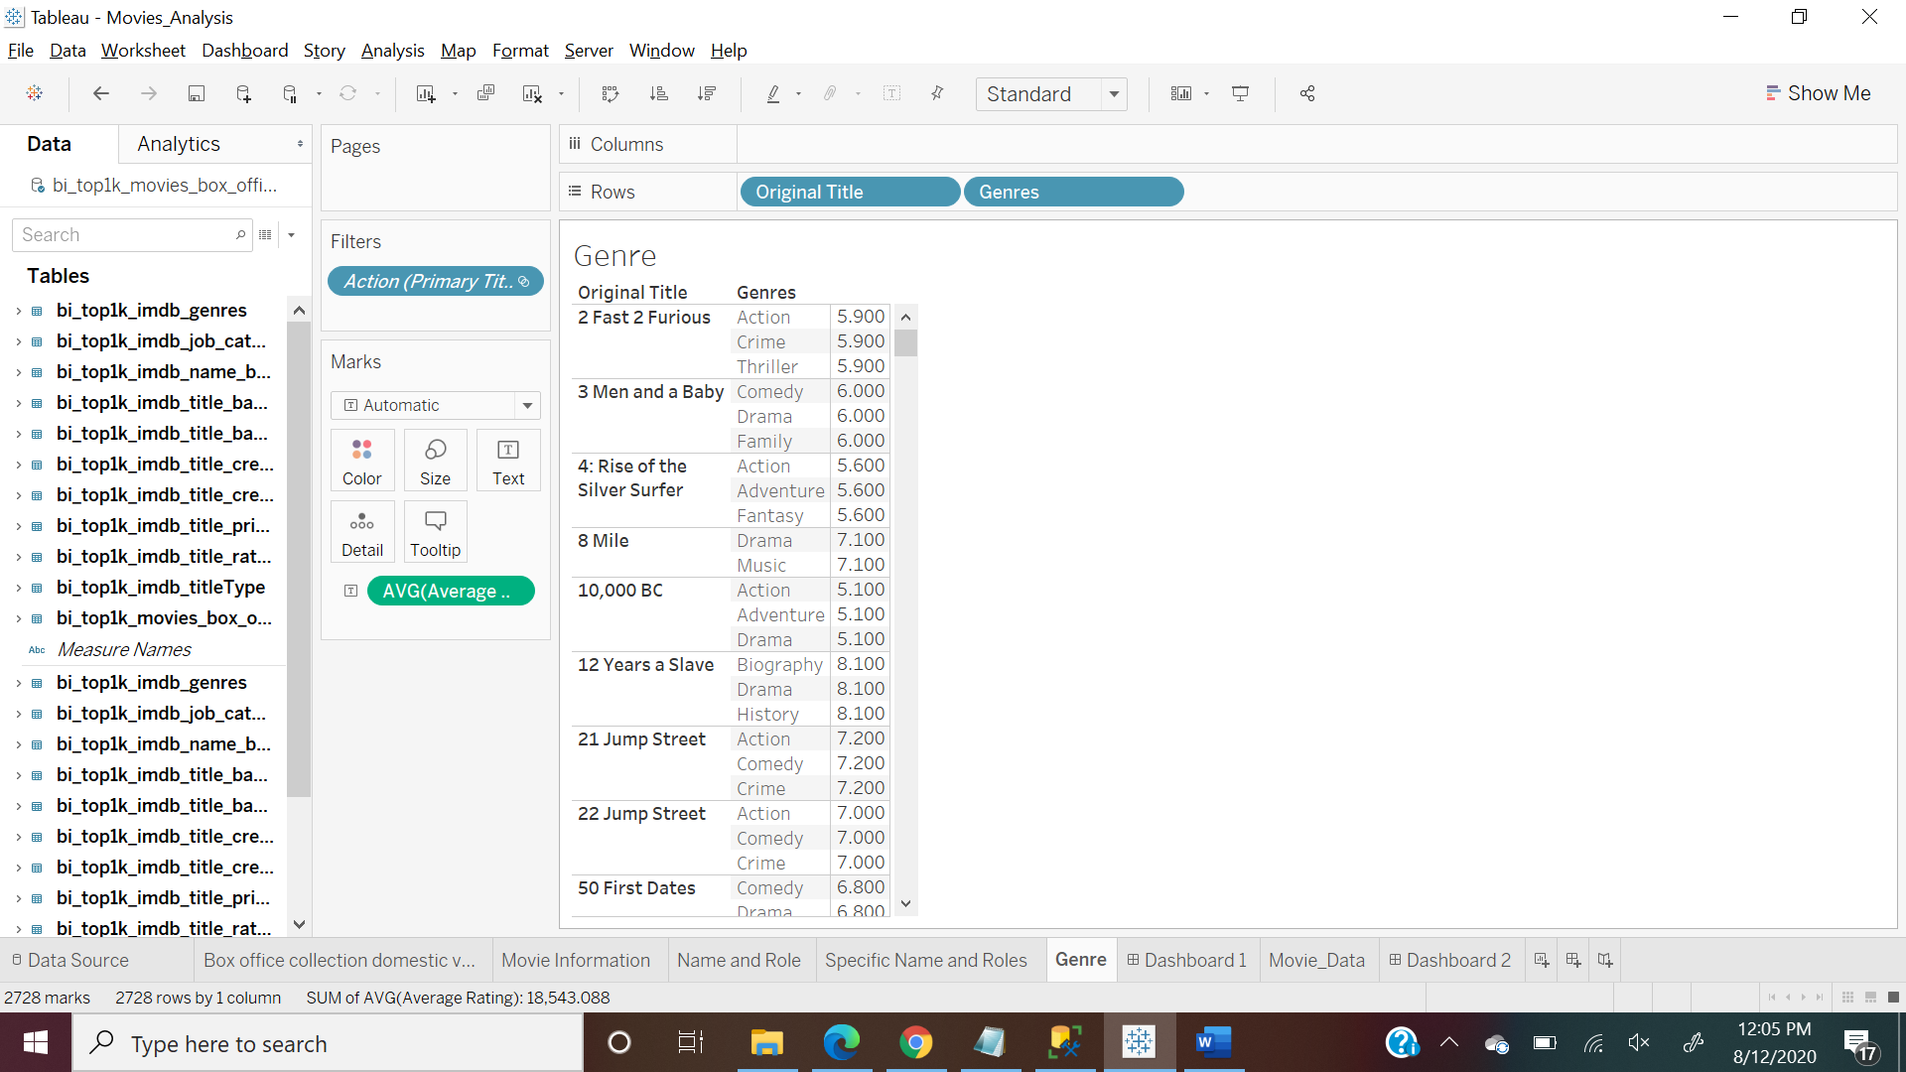

Dashboard 1

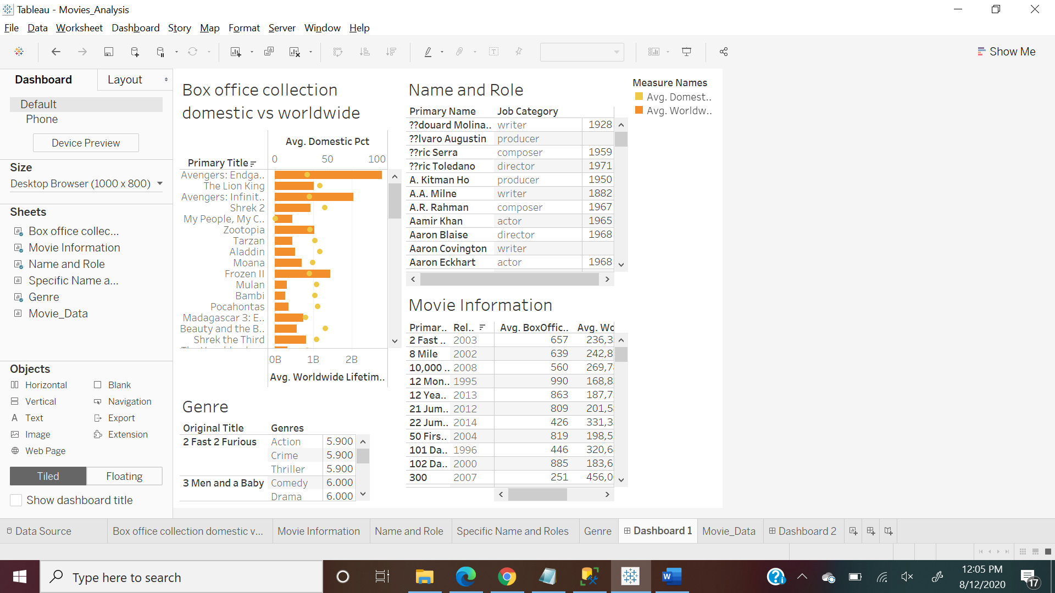

After selecting value “Avenger: Endgame”

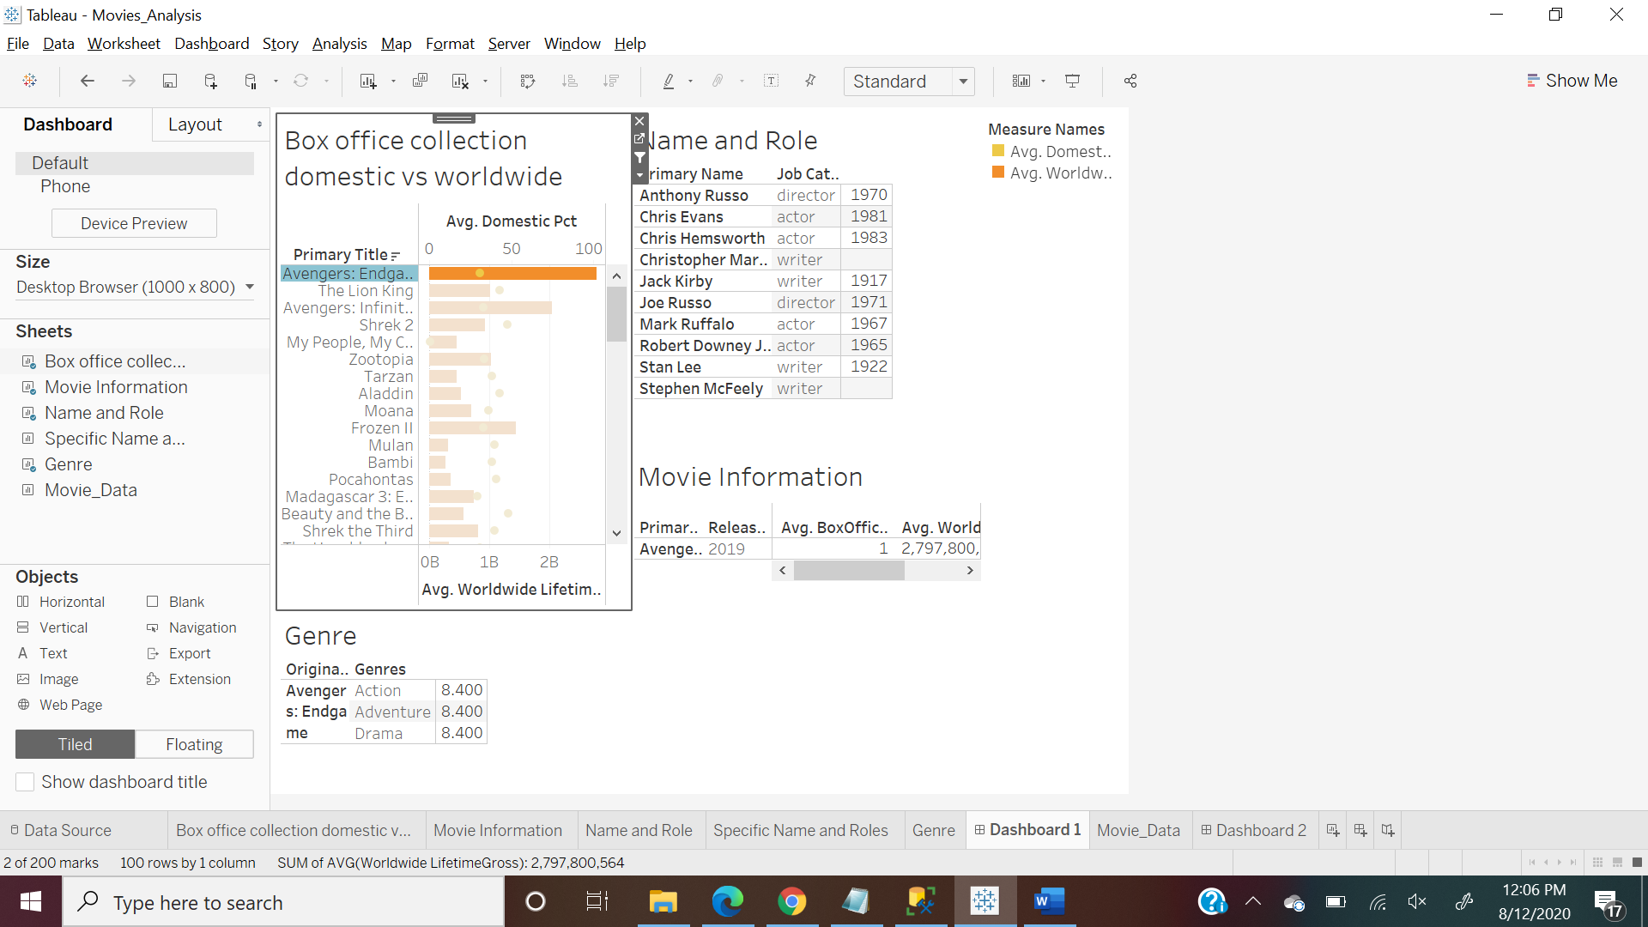

Dashboard 2:

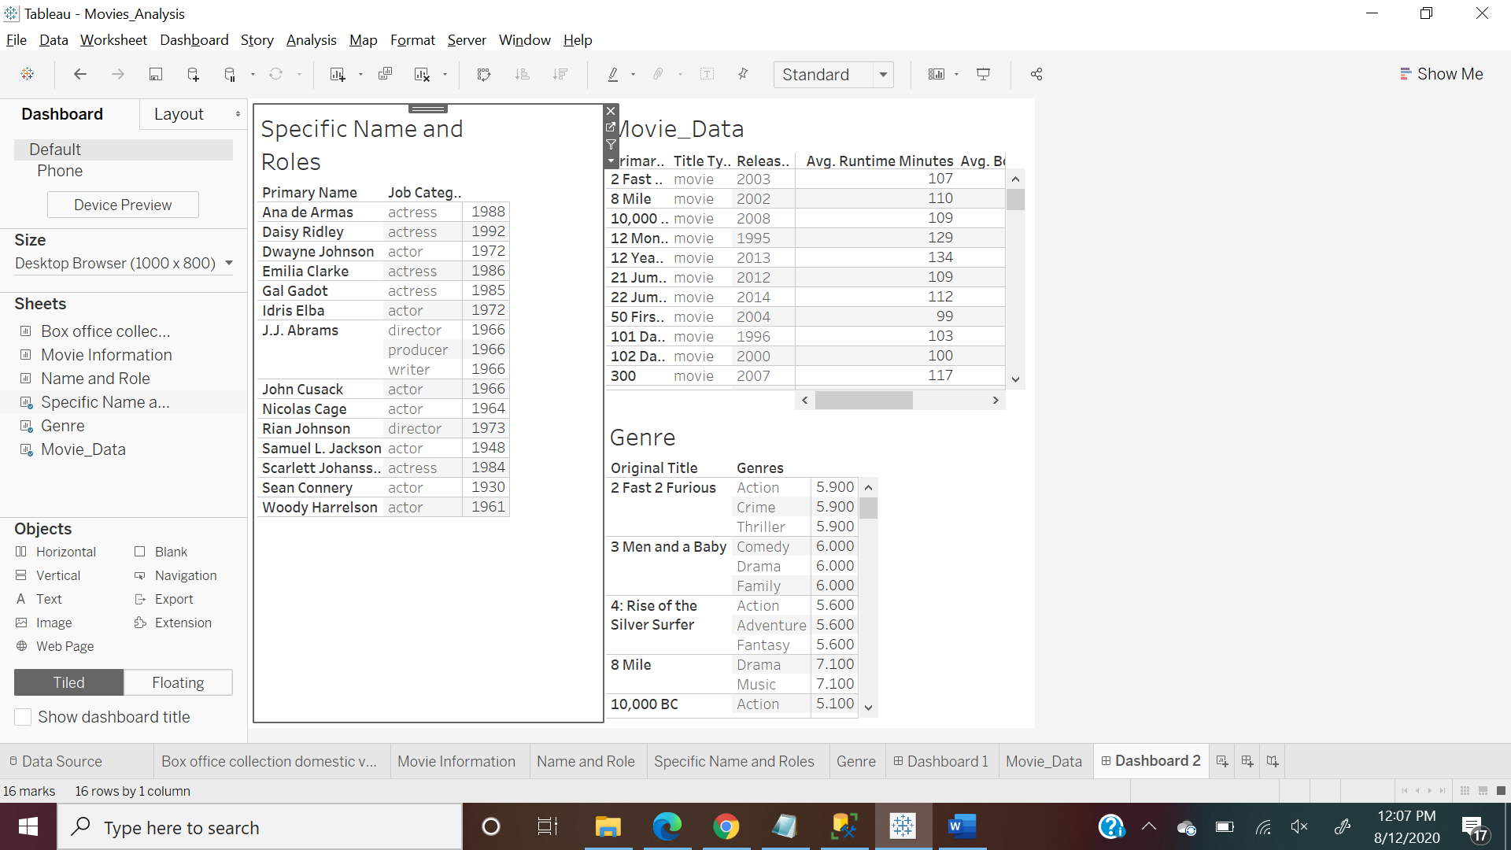

After selecting value “Emilia Clarke” its showing list of movies associated with name and genres of those movies

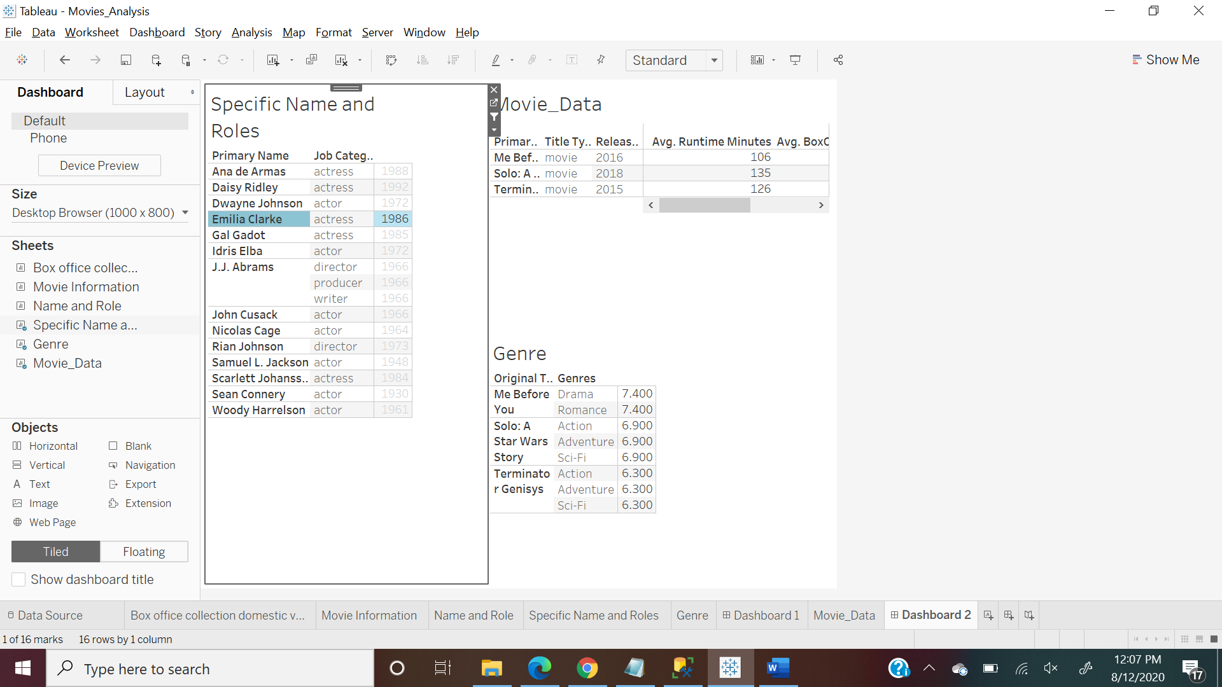

1. **IMDB Title Analysis**

This graph is showing top 25 ranked titles under each Title Type (Used Index)

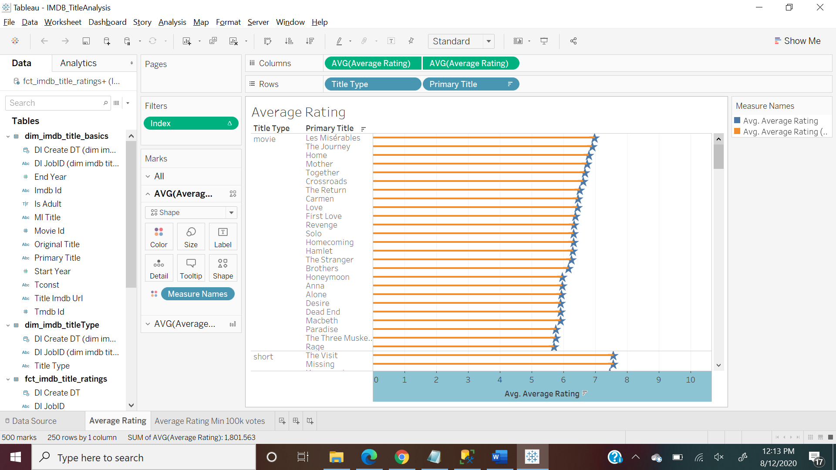

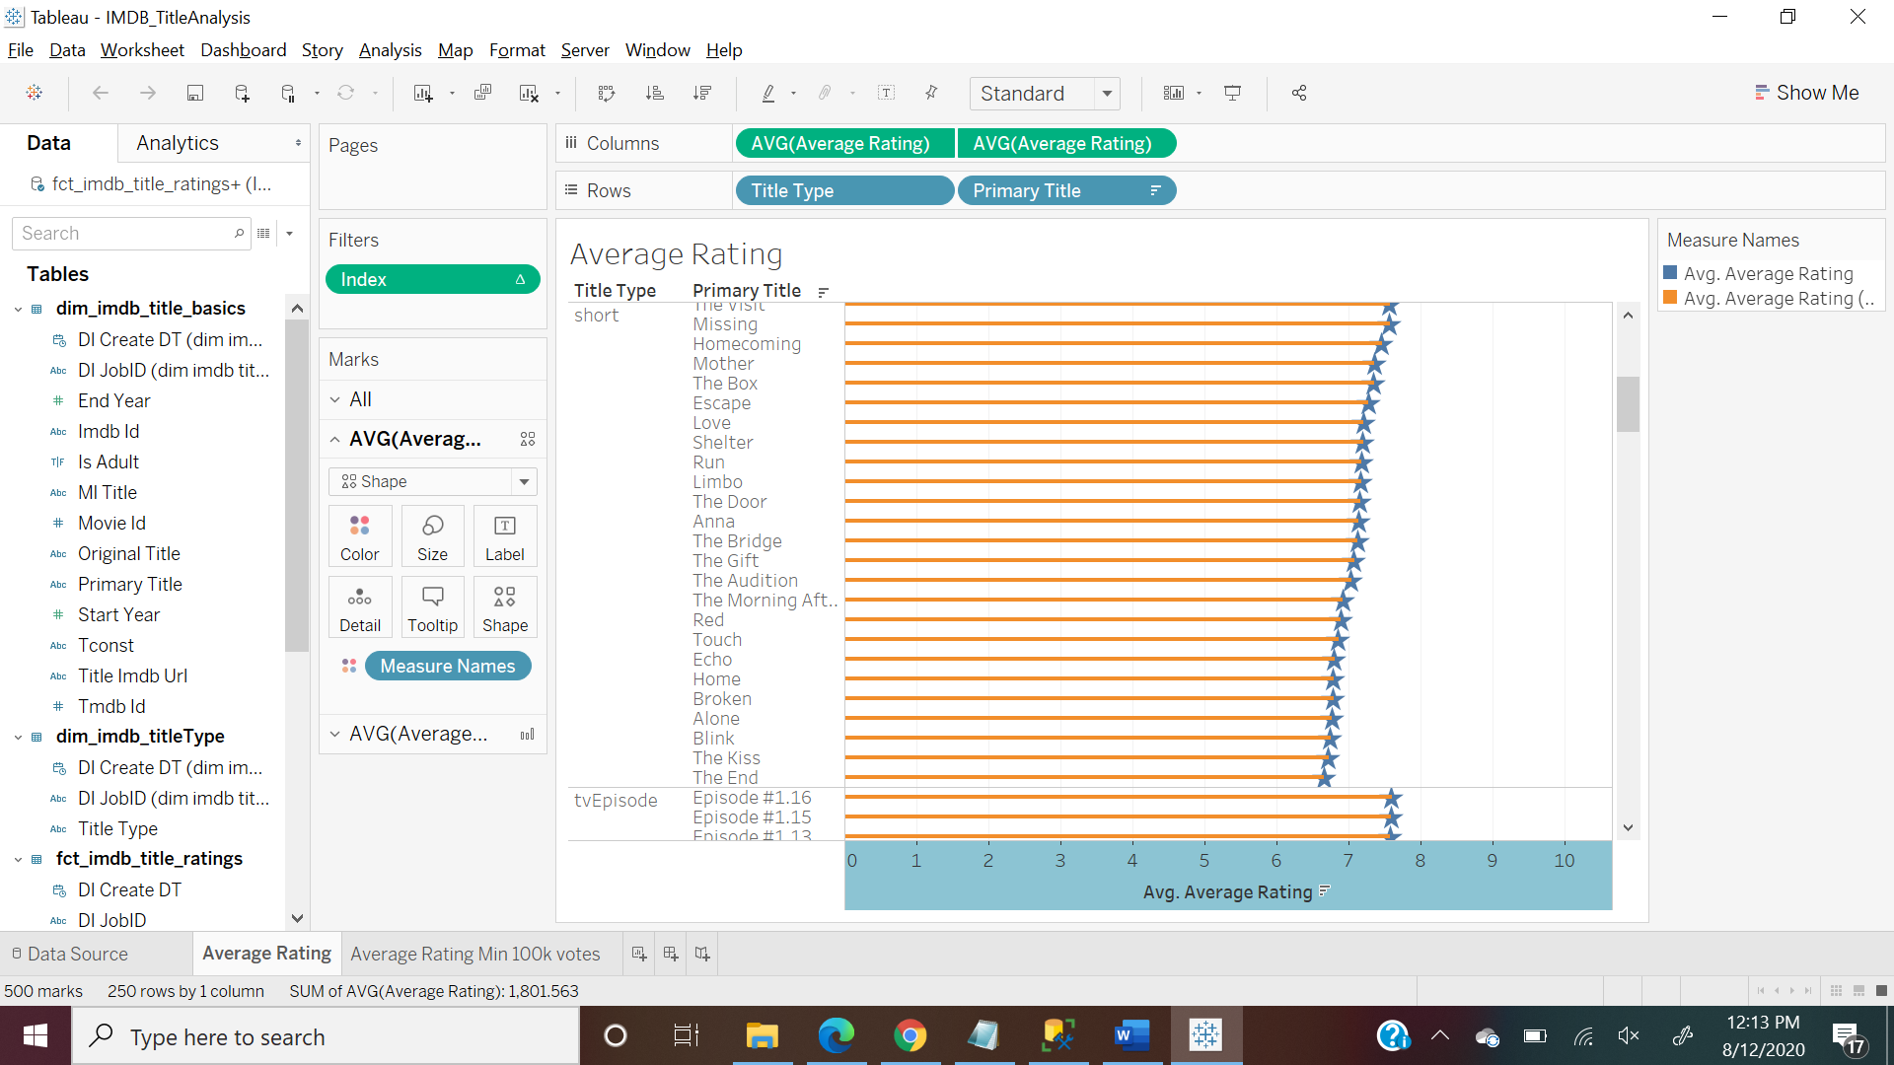

With greater than 100K votes

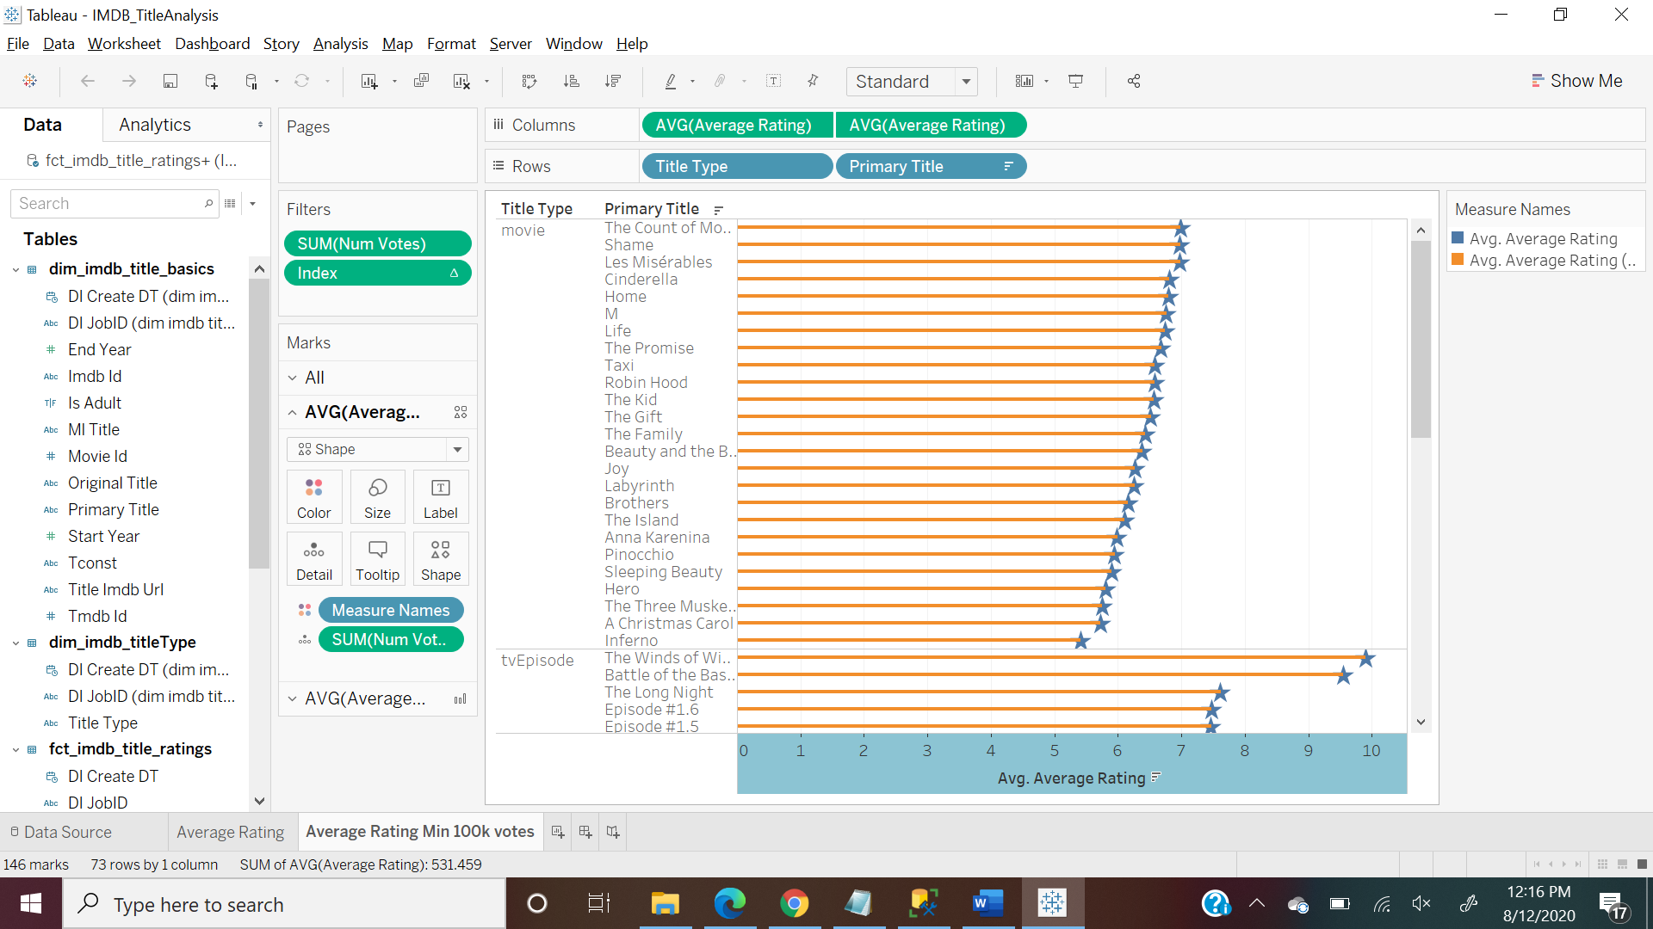

1. ML title analysis

This graph is showing data for top 25 movies across all genres and their ratings on Movie Lens and IMDB

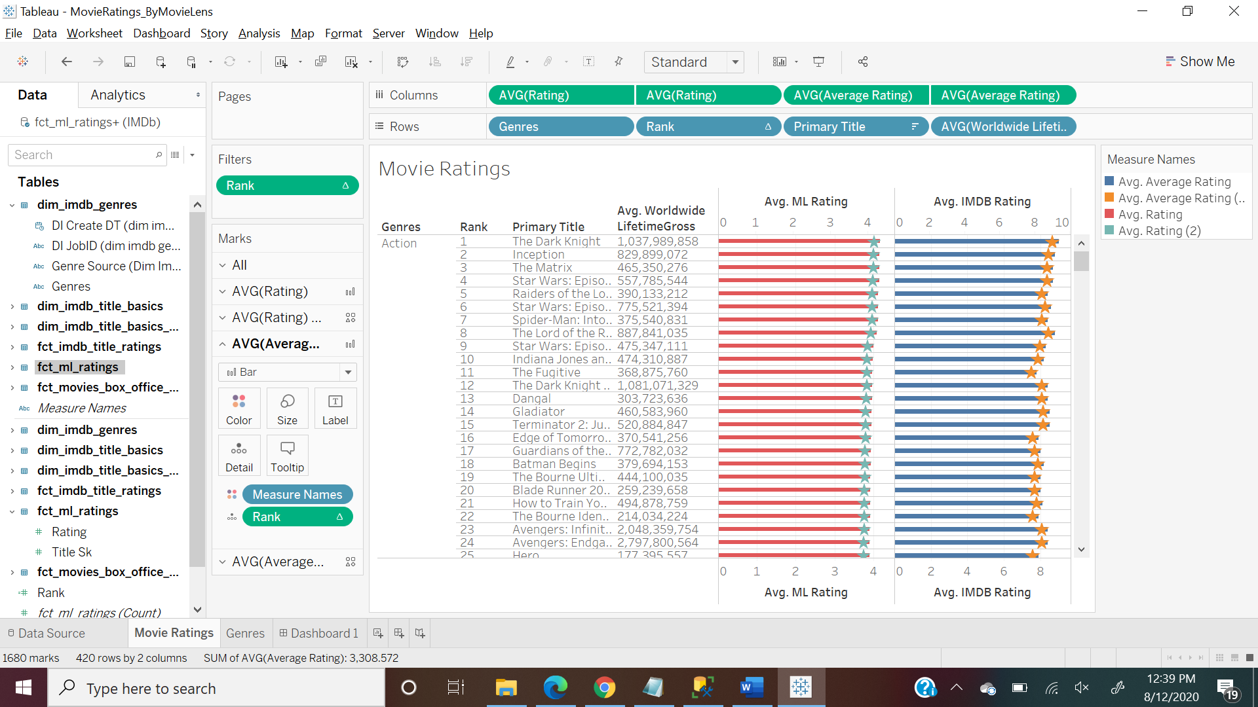

Available Genres and their average ratings in IMDB and ML

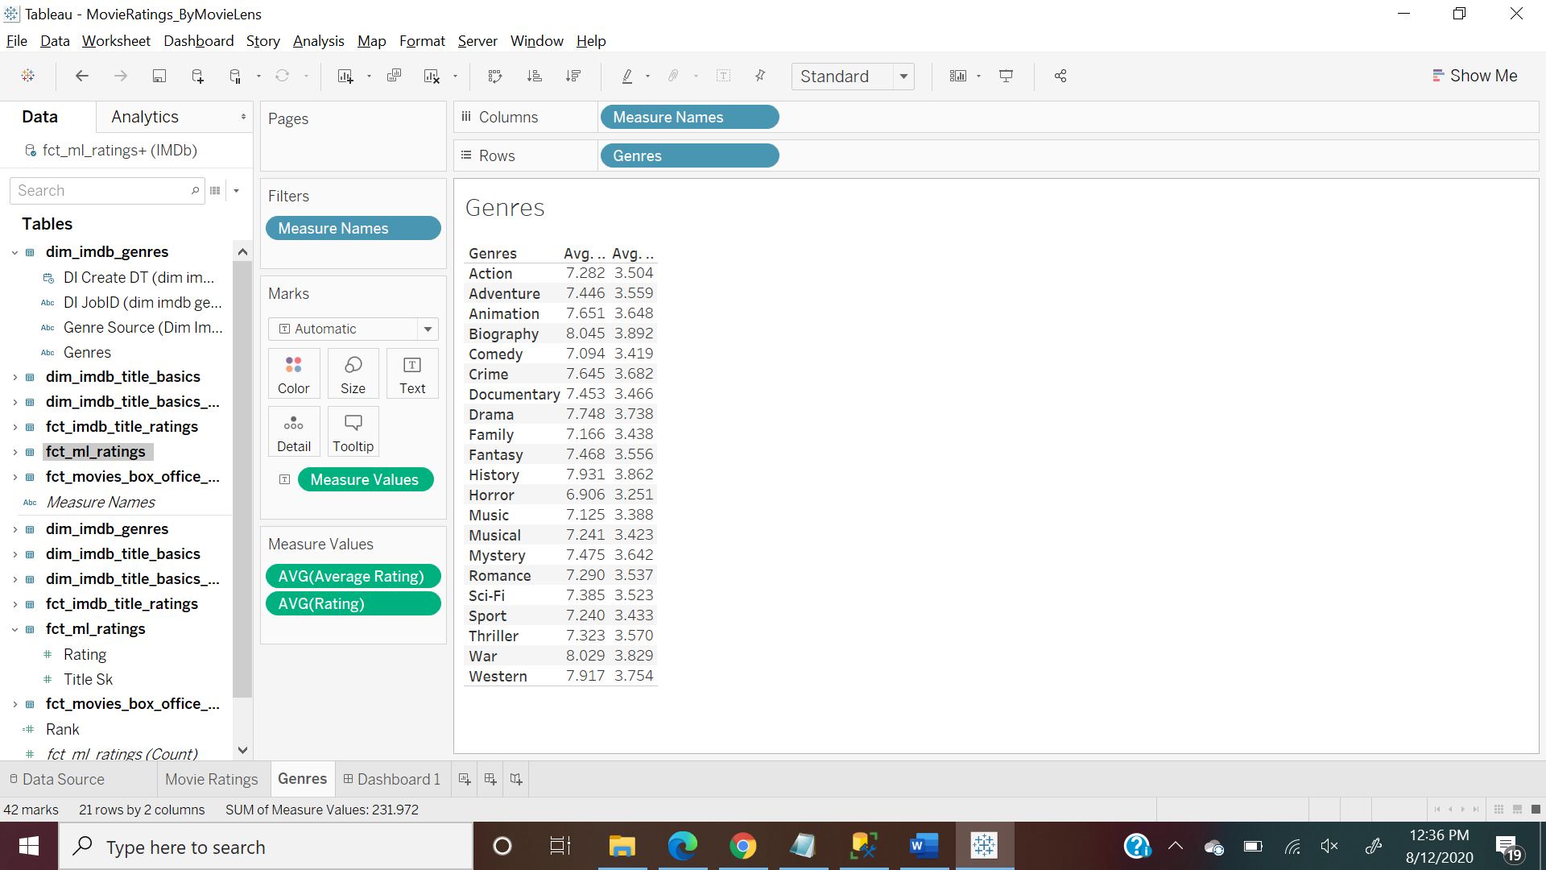

After selecting a particular Genre, its showing respective Ranks, Titles and Ratings

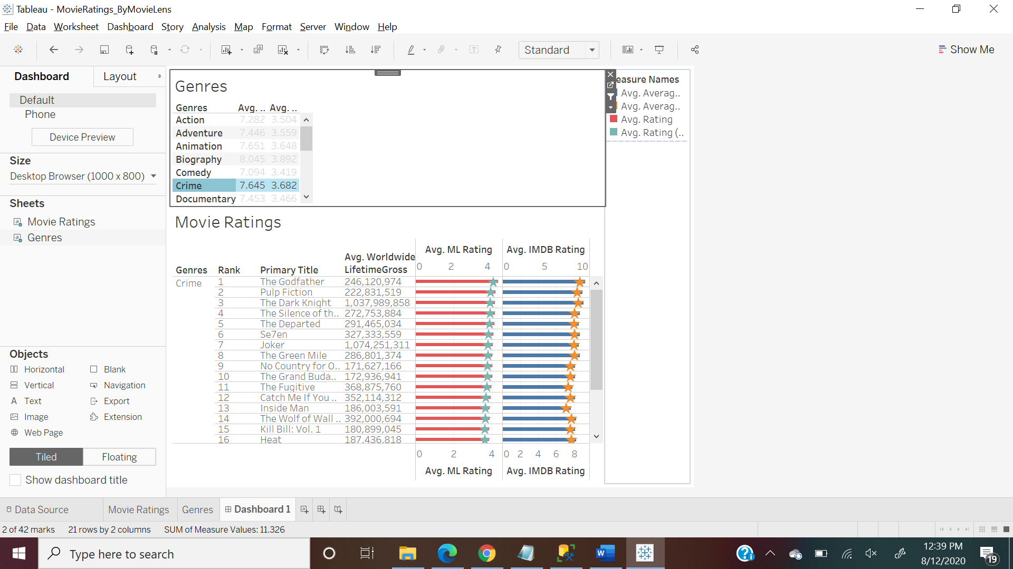

**Power BI Visualizations**

1. Movies Revenue and Ratings

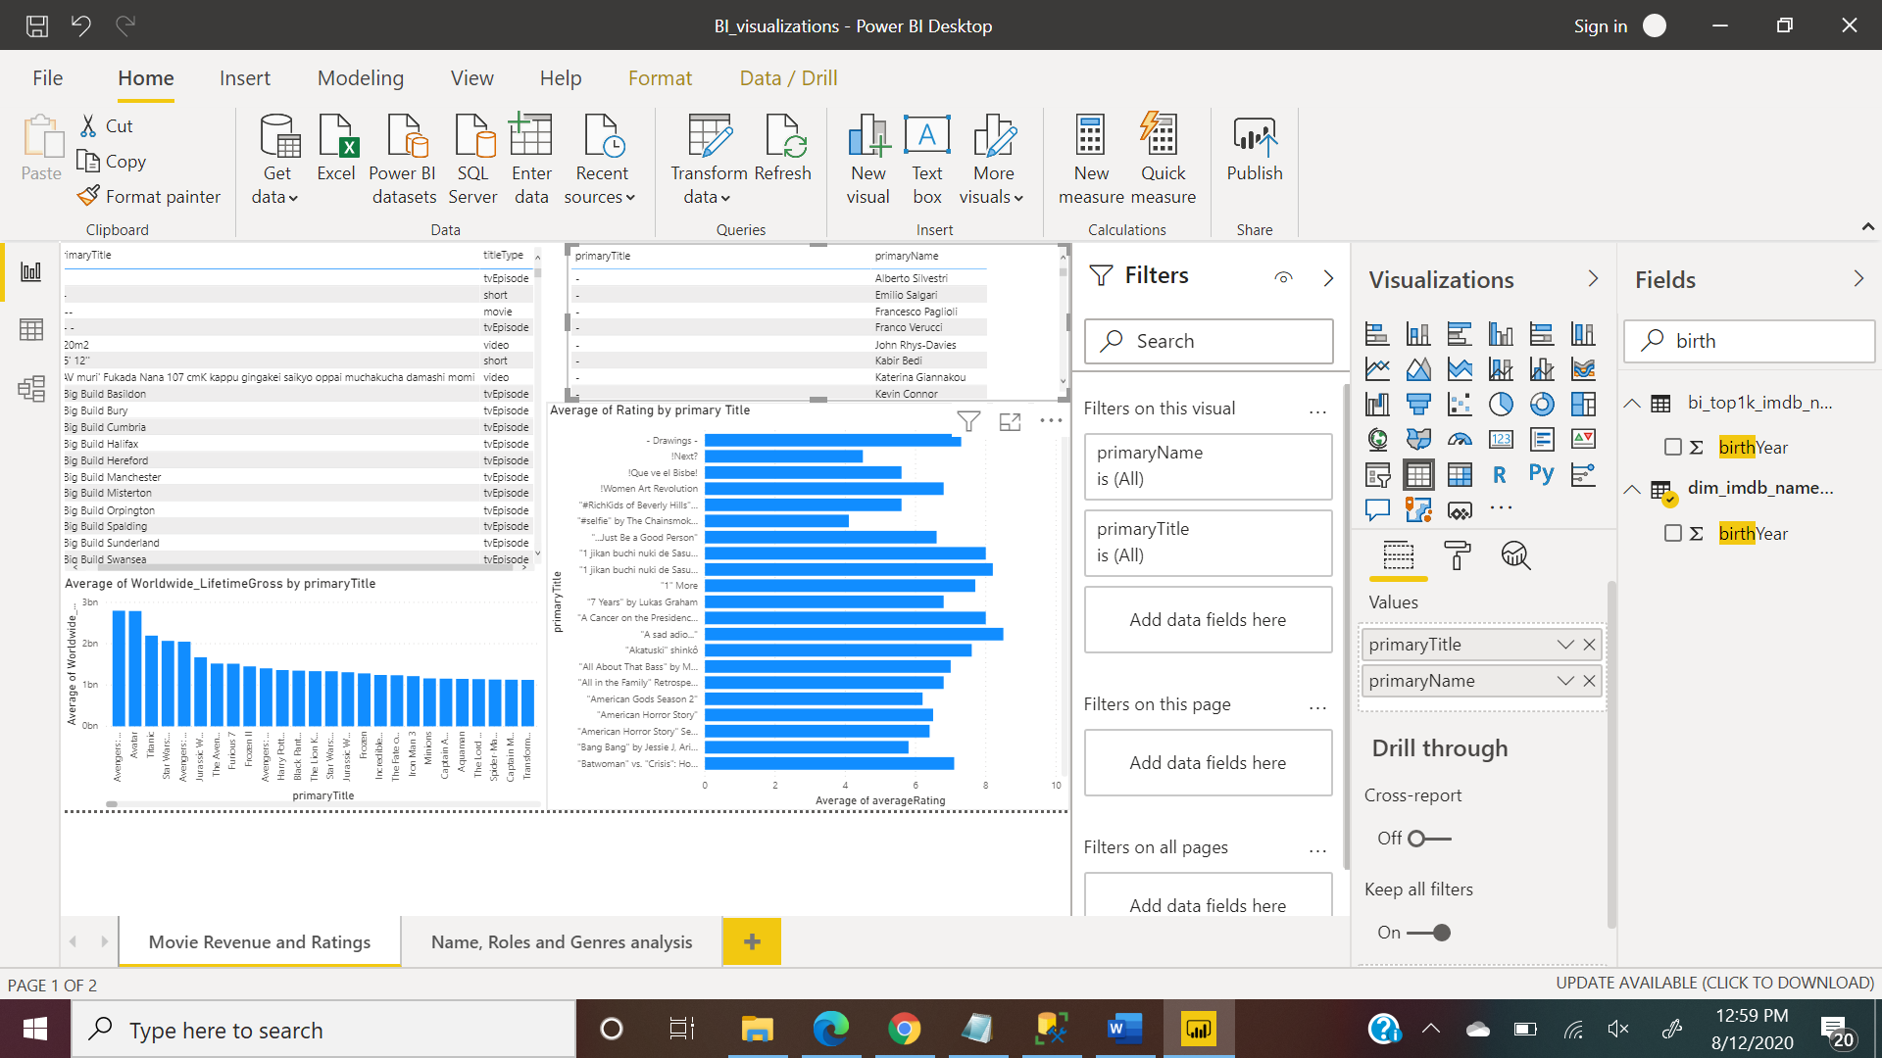

1. Names, Job Roles and Genres Analysis

